CASE/PROBLEM BASED TEMPLATE
IDENTITAS MATAKULIAH
Matapelajaran: | Ledership
Pokok Bahasan: | Leadership Behavior
Sub Pokok Bahasan: | Studies of Leadership Behavior, The leadership Pipeline, Community Leadership, and Assessing Leadership Behaviors.
CPMK | -
Sub CPMK | -
Kasus/Problem: | Enron’s Bankruptcy in 2001
SCRIPT – INTRODUCTION/ORIENTASI PADA MASALAH
Orientasi pada masalah/Defining the Problem (Open ended problem/Real life Problem)
KASUS/PROBLEM A  Enron's bankruptcy in 2001 stemmed from leadership failures, driven by unethical behavior, lack of accountability, and a culture of deception. CEO Kenneth Lay and other top executives, once seen as charismatic leaders, succumbed to greed and arrogance, leading to unsustainable expansion and a disregard for rules. This case highlights the crucial need for ethical leadership, corporate governance, transparency, and accountability in business. It spurred reforms and raised awareness of the consequences of leadership misconduct. |  | KASUS/PROBLEM B
SCRIPT – ANALISIS MASALAH
1. Tiap kelompok Brainstorming
group 1: the case is great example for a leadership behavior. bcs the leader should be ethical, transparent, bcs the leader is a very important role.
group 2: the material is really related with the material since the material explained about leadership behavior and your case mention that the caused of the Enron's bankruptcy because of their leader was greed and arrogance (which is kind of misbehaviour).
Its important for the company to have a division to supervise the leader, so they will not doing misbehaviour that could harm the corporate.
group 3: The case is related with the material and it's a good example of the importance behavior of a leader. Because the material talk about how should a leader behave and the case discusses what happens if a leader does not behave like a leader should be.
group 4: The main point of the Enron's bankruptcy case is that it was primarily caused by a severe breakdown in ethical leadership and corporate governance. The case underscores how unethical behavior, driven by greed and a lack of accountability, led to the downfall of a once-prominent company. The main takeaways from this case are the importance of ethical leadership, transparency, and adherence to regulations in maintaining the integrity and sustainability of any business. It serves as a cautionary tale about the devastating consequences of unethical conduct at the highest levels of an organization and the need for stricter oversight and reforms in corporate governance.
group 5: I think the case is already related to the materials. I think, Enron Bankcruptcy happened because they really do not understand about the important of leadership behaviors, so they experience failure. From Enron’s Bankruptcy we can understand strategic thinking, decision making, emotional intelligence, and the ability to influence others.
group 7: In my opinion, this is an example of leader behavior that we should avoid. The CEO may have good charisma but it is not used well by carrying out reckless expansion and breaking the rules. Due to this behavior the company experienced bankruptcy.

2. Alternatif Solusi
To avoid this kind of situation, the following solutions can be implemented:
- Leaders with Integrity: Ensure that company leaders have high integrity and are accountable for their actions.
- Leader Engagement: Company leaders should be actively involved in key decision-making and ensure transparency in all aspects of company operations.
- Promotion of an Ethical Culture: Leaders should promote a culture of ethics throughout the organisation, emphasising the importance of ethical behaviour in business.
- Performance Monitoring: Leaders should closely monitor performance, not only in terms of finances, but also in terms of corporate culture and employee behaviour.
SCRIPT-PROBLEM SOLVING ACTIVITES
4. Mengumpulkan informasi dan Pengembangan Solusi
To avoid such situation, the following solutions can be implemented:
- Dissolution of Enron: Enron was dissolved, and its assets were liquidated through the bankruptcy process.
- Investigations and Legal Actions: Investigations led to convictions of key Enron executives and legal actions against those involved in the fraud.
- Sarbanes-Oxley Act: The Sarbanes-Oxley Act (SOX) was passed, introducing regulatory reforms in corporate governance, financial reporting, and auditing.
- Recovery for Creditors and Shareholders: Some funds were recovered for Enron's creditors and shareholders, but not all losses were fully recouped.

4. Presentasi (Sharing) dan Penyajian Hasil Karya
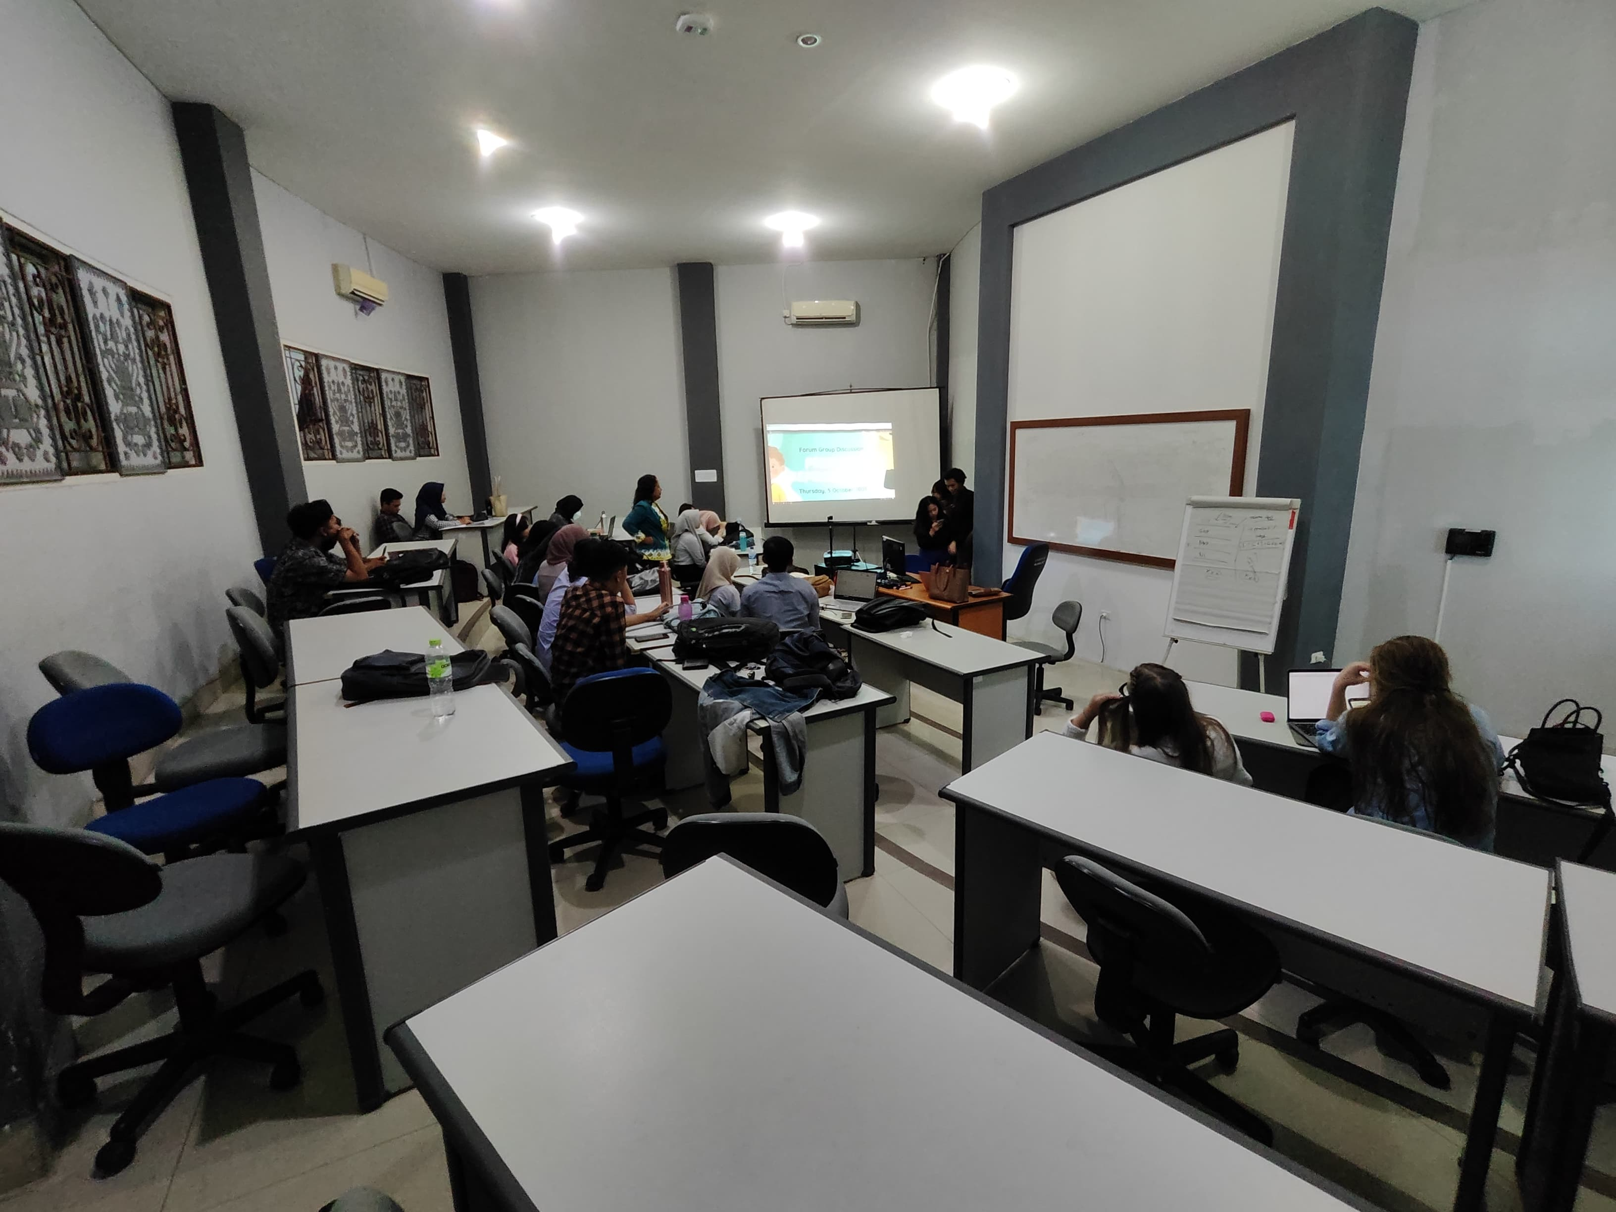

Group 6 link youtube presentation:
- Bintang Nadhiva B. (2211011020): https://youtu.be/x1TJSB8IOgg?si=UCOWwoSp2KAzomQp
- Rhea Natania M. S. (2211011029): https://youtu.be/AQxyBQc4GvQ?si=KQR5N7XDRozpDMiu
- Arif Rahmansyah (2211011123): https://youtu.be/a_wNEU15z8I?si=iYyoL_0KGKaJu3kX
- Muhammad Fathurrohman (2211011133): https://youtu.be/OAqoAIXvivc?si=MgcmIsMtq-y8YjXY

SCRIPT-REFLEKSI DAN TINDAK LANJUT
Enron's bankruptcy in 2001 stemmed from leadership failures, driven by unethical behavior, lack of accountability, and a culture of deception. CEO Kenneth Lay and other top executives, once seen as charismatic leaders, succumbed to greed and arrogance, leading to unsustainable expansion and a disregard for rules. This case highlights the crucial need for ethical leadership, corporate governance, transparency, and accountability in business. It spurred reforms and raised awareness of the consequences of leadership misconduct.

Validate
Date:

Lecturer: (1) (2) (3)

