CASE/PROBLEM BASED TEMPLATE

IDENTITAS MATAKULIAH
Matapelajaran: | Leadership
Pokok Bahasan: | Leadership Attributes

Sub Pokok Bahasan:
CPMK | Knowing the relationship between Personality Traits and Leadership  Knowing the relationship between Personality Types and Leadership  Understand the important of Intelligence in Leadership  Understand the relationship between Emotional Intelligence and Leadership

Sub CPMK
Kasus/Problem: | The leadership style of director PT. KAI

SCRIPT – INTRODUCTION/ORIENTASI PADA MASALAH
Orientasi pada masalah/Defining the Problem (Open ended problem/Real life Problem)
KASUS/PROBLEM A  In leading Jonan uses the principle of leading by example. This aims to make his employees able to work and follow directions in order to achieve the goals to be achieved.  In Jonan's leadership era, he was able to change in terms of the mindset that occurred to the community through the use of technology from the replacement of the conventional ticket system to the e-ticketing system. the culture of queuing and orderly entry and exit of the station through one door is also familiarized. As well as a decrease in the number of free riders, it can be seen through the increase in the number of KRL passengers, namely within a month of e-ticketing being implemented, there was an increase in the number of users by 20%, namely 575,134 KRL users per day. |  | KASUS/PROBLEM B

SCRIPT – ANALISIS MASALAH

1. Tiap kelompok Brainstorming

Personality is an important things in leadership because personlity affect how they in an organization.

There is so much assessment to determine a personality such as big 5 theory abd MBTI.

There is a relationship between leader intelligence and experience level. The performance of a leader is a combination between intelligence and experience

Leader not just need to have a good intelligence but also a good emotional intelligence. This will help a leader to control their emotion and their team emotion.

2. Alternatif Solusi

A leader should have a balance between personality, intelligence, and emotional intelligence in leadership. all three have an important role in achieving company goals and also in managing member satisfaction. the above can be developed by conducting several assessments, evaluating, and continuing to improve the above.

SCRIPT-PROBLEM SOLVING ACTIVITES

4. Mengumpulkan informasi dan Pengembangan Solusi

Understanding the relationship between personality traits and leadership is crucial. Certain traits, such as extraversion, conscientiousness, and openness, are often associated with effective leadership. These traits can contribute to a leader's ability to inspire and guide a team. Personality types, often assessed through tools like the Myers-Briggs Type Indicator (MBTI), can provide insights into leadership styles. Different personality types may excel in various leadership roles. Intelligence, both in terms of cognitive and emotional intelligence, also plays a critical role in leadership. Cognitive intelligence helps leaders make informed decisions and solve complex problems, while emotional intelligence enables them to understand and manage their own emotions and those of their team members, leading to better interpersonal relationships and team dynamics. Meanwhile, Leaders with high emotional intelligence can navigate complex social situations, inspire trust and loyalty, and effectively manage conflicts.

4. Presentasi (Sharing) dan Penyajian Hasil Karya

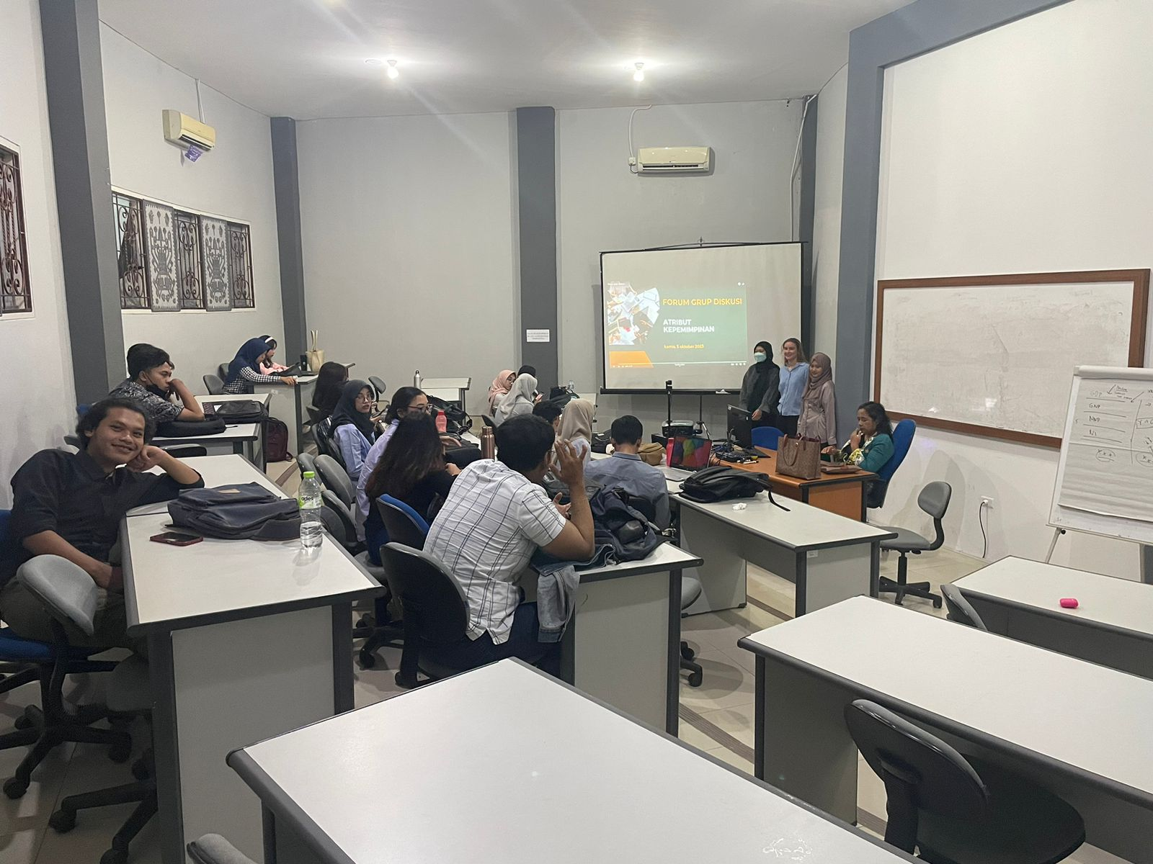

-Rafa Nithalaida (2211011065)
https://youtu.be/OJ3xvAZX1DM?si=vpbsTgE4YgJwYW7q

-Tiara Rizky Cahya (2211011140)
https://youtu.be/TS_oeCOGtb4?feature=shared

-Anna Radionova (PB23111011001)
https://youtu.be/Seu4A8WkN4U?feature=shared

SCRIPT-REFLEKSI DAN TINDAK LANJUT

In conclusion, Jonan's leadership style, characterized by leading by example, had a transformative impact on the community during his era. Through the introduction of technology and the shift from a conventional ticketing system to e-ticketing, Jonan not only improved the efficiency of the transportation system but also influenced a change in societal mindset. The adoption of e-ticketing promoted a culture of queuing and orderly station entry and exit, significantly reducing free riders.

The results were remarkable, with a substantial 20% increase in the number of KRL passengers within just a month of implementing e-ticketing. This case exemplifies the power of effective leadership in fostering positive changes in both technology adoption and cultural shifts within a community. Jonan's approach of leading by example contributed to the success of this transformation.

Validate

Date: 5 Oktober 2023

Lecturer: (1) (2) (3)

