CASE/PROBLEM BASED TEMPLATE

IDENTITAS MATAKULIAH
Matapelajaran: | Leadership
Pokok Bahasan: | Focus on the leader
Sub Pokok Bahasan: | Leadership, ethics & values

CPMK

Sub CPMK
Kasus/Problem: | Ethics is considered to be able to eliminate dirty business practices

SCRIPT – INTRODUCTION/ORIENTASI PADA MASALAH
Orientasi pada masalah/Defining the Problem (Open ended problem/Real life Problem)
KASUS/PROBLEM A  According to Professor at the Faculty of Business Economics, University of Indonesia, Cynthia Afriani Utama, there are still many companies that get around taxes (transfer pricing), unclean policies, unethical culture. So ahw considered that it was necessary for an individual's ability or moral awareness to differentiate between right and wrong actions.  Ethical violations in business practices in Indonesia are a serious problem that can damage a company's integrity and reputation and destroy public trust. So good strategies are needed, such as increasing awareness and training related to business ethics, to prevent it.  However, she reminded that cooperation between the government, business sector and civil society is very important in fighting ethical violations and promoting fair and responsible business practices. |  | KASUS/PROBLEM B

SCRIPT – ANALISIS MASALAH

1. Tiap kelompok Brainstorming

group 1: ethics is very influential in preventing dirty practices by business people.

group 2: the importance of paying taxes to support governance so that moral leadership is maintained.

Group 3: Business people must be able to distinguish between good and bad actions so that ethics are maintained.

group 5: the importance of moral awareness of business people in order to avoid unethical and unlawful actions.

group 6: the importance of ethics to maintain the integrity and reputation of the company.

group 7: the need for individual awareness in handling matters of corporate ethics to create a business environment with integrity in Indonesia.

2. Alternatif Solusi

Creating an ethical climate is not easy or just a matter of following a simple recipe. Conflicts over values can arise even when an organization has clearly published values that are embraced by everyone. That can happen when employees and leaders have divergent perceptions of whether the leader’s behavior embodies important

corporate values.

SCRIPT-PROBLEM SOLVING ACTIVITES

4. Mengumpulkan informasi dan Pengembangan Solusi

Ethical violations in business practices in Indonesia are a serious problem that can damage a company's integrity and reputation and destroy public trust. So good strategies are needed, such as increasing awareness and training related to business ethics, to prevent it.

cooperation between the government, business sector and civil society is very important in fighting ethical violations and promoting fair and responsible business practices.

4. Presentasi (Sharing) dan Penyajian Hasil Karya
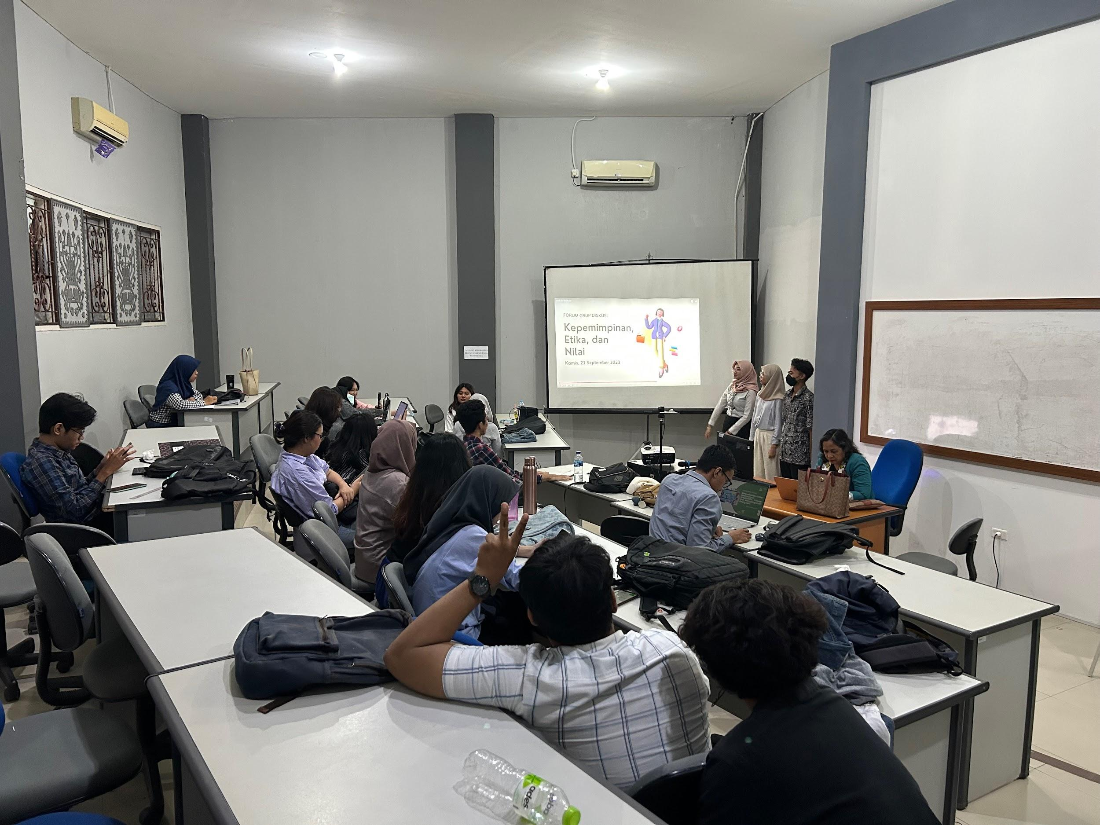

Group 4:
- Cika Nandita Roesly (2211011116)
https://youtu.be/NiVH1vUkHWY?feature=shared

- Khoirul Anam (2211011173)
https://youtu.be/AmPsGjwUcUA?si=JcXw6g5NjJdZlsVr

- Fauzi Arfan (2251011013)
https://youtu.be/Pk6-6mut6RY?feature=shared

- Zahwa Nura Aziza (2251011030)
https://youtu.be/WFQct-cMWMc?si=IVV46gJeWKfgnnKJ

SCRIPT-REFLEKSI DAN TINDAK LANJUT

According to Professor at the Faculty of Business Economics, University of Indonesia, Cynthia Afriani Utama, there are still many companies that get around taxes (transfer pricing), unclean policies, unethical culture. So he considered that it was necessary for an individual's ability or moral awareness to differentiate between right and wrong actions.

Ethical violations in business practices in Indonesia are a serious problem that can damage a company's integrity and reputation and destroy public trust. So good strategies are needed, such as increasing awareness and training related to business ethics, to prevent it.

Validate

Date: 30 Agust 2023

Lecturer: (1) (2) (3)

